Ekalavya’s AI

Ekalavya – Self Learner AI – Generative AI

# **1. Abstract**

This project aims to transform the exam preparation process by making use of the capabilities of AI to generate question papers. It provides an efficient, structured approach for students and educators to focus their efforts on key topics. The tool allows users to upload a syllabus and past question papers, which are analysed to predict likely exam questions. By utilizing Gemini's language modelling capabilities, the system identifies patterns and trends in exam formats, creating comprehensive and well-organized question sets.

The project integrates AI-powered natural language processing with a user-friendly interface developed using Streamlit, making it accessible to individuals of varying technical expertise. Users can easily upload files and retrieve the generated questions in formats like PDF and CSV, ensuring convenience and flexibility. Preliminary evaluations demonstrate the system’s ability to accurately predict relevant questions that align with syllabus content and historical exam trends. This ensures that students can concentrate on high-priority topics, optimizing their preparation process and saving valuable time.

The interface is designed with accessibility and ease of use in mind, enabling quick access to insights for targeted study. Future enhancements aim to incorporate additional data sources, expand user customization options, and improve compatibility with diverse curriculum standards. By making exam preparation more efficient, focused, and tailored to individual needs, this project demonstrates the transformative potential of AI in enhancing academic outcomes for students and educators alike.

# **2. Introduction**

In today's education-driven world, studying for exams can be overwhelming for both students and educators. The challenge of predicting likely exam questions based on extensive syllabi and past papers can leave students uncertain about where to focus their preparation. As the demand for smarter and more focused study tools grows, advancements in artificial intelligence offer a fresh approach to this problem. This project introduces the Question Paper Generator, a tool designed to assist students and educators in exam preparation by leveraging intelligent question prediction and generation.

The Question Paper Generator streamlines the exam preparation process by enabling users to upload syllabi and previous question papers. These inputs are analysed by the system's advanced AI capabilities, which predict potential exam questions, ensuring students can prioritize their efforts on the most relevant topics. Built with an intuitive interface using Streamlit, the application is accessible to users of all technical backgrounds. Outputs are provided in PDF and CSV formats, allowing students to review, share, or print the generated question sets effortlessly.

At the core of this system lies Google's Gemini AI, a powerful language model that processes input data to identify trends and patterns in question formats and subject coverage. The tool integrates seamlessly with various file formats, making it easy for users to upload syllabus PDFs and previous papers. Its streamlined design ensures that students spend less time managing materials and more time actively preparing for their exams, offering a more efficient and focused approach to studying.

In conclusion, the Question Paper Generator is a tool for both students and educators. By automating question prediction and focusing on curriculum relevance, it simplifies exam preparation. As education continues to advance in a technology-driven world, this project highlights the potential of AI-powered tools to enhance learning outcomes and support academic success.

# **3. Proposed Work**

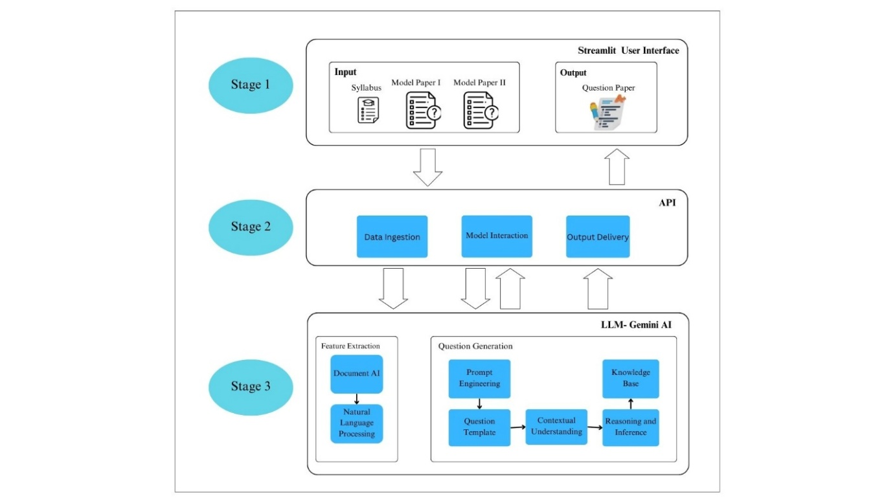

**Stage 1** - **Input and Output**:

* Inputs: **Syllabus** and **Model Papers I & II**.
* User Interface: Built using **Streamlit**.
* Output: **Generated Question Paper**.

**Stage 2** - **API Layer**:

* **Key Processes**:
  + **Data Ingestion**: Collecting and processing inputs.
  + **Model Interaction**: Communicating with AI models.
  + **Output Delivery**: Sending results back to the user interface.

**Stage 3** - **LLM-Gemini AI Processing**:

* **Feature Extraction**: Utilizing **Document AI** and **Natural Language Processing (NLP)**.
* **Question Generation**:
  + **Prompt Engineering** and **Question Templates**.
  + Contextual understanding using **Knowledge Base** and **Reasoning and Inference** capabilities.

# 6. **EXPERIMENTAL** **RESULTS**

Gemini AI is exclusive and has a specific internal architecture. It manipulates words but can also understand the context, concepts, emotions, intentions, and relationships behind the data. Q paper generation is in its general approach to capability.

Key Components and Process:

**LLM:**

The Gemini AI core is capable of understanding and generating human language as it is trained with massive amounts of data. Such huge data is obtained as texts and code from textbooks, research papers, and code repositories. This also enables the model to understand different subjects and generate relevant questions by identifying the key concepts.

**Document Understanding and Processing**

**Document AI:**

Document AI refers to a field of technology that employs machine learning (ML) techniques to extract text from images or PDF documents (Syllabus and sample papers). It uses different techniques like OCR (Optical Character Recognition).

**Natural Language Processing (NLP):**

NLP enables computers to understand, interpret, and produce human language. NLP is used to understand the text extracted from the PDF documents. It is also used to identify key topics, subtopics, and important concepts.

**Question Generation:**

**Prompt Engineering:**

Prompt Engineering is a process that involves providing the model with instructions, examples, and context to help it understand the intent of the request and respond appropriately. This involves a fundamental process of generating or crafting prompts to guide the question-generation process by LLM.

**Question Templates:**

A questionnaire template is a pre-designed format with a structured set of questions, allowing you to easily customize questions and response options based on your specific research needs while maintaining a consistent structure and being prepared before question paper prediction. Types of Question papers (like multiple-choice, short answer, and essay) are also prepared from these templates.

**Contextual Understanding:**

This is the ability of AI to consistently improve its LLM’s understanding of the syllabus and sample papers to generate suitable questions. The questions generated must explicitly be relevant to the subject, challenging but doable, and aligned with a goal and learning objectives.

**Knowledge base:**

AI knowledge bases can be more dynamic than traditional knowledge bases and can provide faster responses to customer queries. Knowledge Base determines the accuracy. The vast the knowledge base is the accurate the information will be and the questions prepared will be. The vast knowledge base is accessed from different sources like textbooks, magazines, etc.

**Reasoning and Inference:**

One key aspect of this is reasoning, enabling machines to conclude, make predictions, and solve problems just like humans. This ability ensures AI to advance in reasoning capabilities. Thus, deriving the better questions from the text and code extracted from the previous year's question papers. Inference is the ability to generate questions from previous question papers to generate output as the new question paper.

**Question Selection:**

The questions are generated from the data given from the Knowledge base, i.e. from the previous year's question papers. The question selection criteria will be distinguished by difficulty level, topic coverage, and question type. This plays a crucial role in preparing a balanced question paper that is not too hard or not too easy.

**Paper Structure:**

Organizes the questions into sections and subsections making it easy to understand. This helps in categorizing related topics ensuring clarity. This also maintains appropriate logic flow, ensures proper weightage, and enhances comprehensive skills.

**Formatting:**

This step formats the question paper according to a few specific guidelines and standards. This helps to maintain consistency and clarity. It also helps in preparing accurate question papers with questions more accurate and organized.

**API Integration:**

**Data Ingestion:**

In this step, input data is given in the form of PDFs. The syllabus (to understand topics to focus on) and previous Year's question papers or sample question papers (to get the input data from) are uploaded here by API. The step is the foundation for our question paper generation model.

**Model Interaction:**

This process involves API interactions with the Gemini API model. The syllabus details and previous year's question papers are provided to the API. This interaction is done by this process. This model also analyses the data and generates relevant questions. Thus, initiating the question-generation process.

**Output Delivery:**

The Gemini API generates the question paper from the input data and sends it to the API. The API then converts the question paper, in the required format (Like PSF, Word) to the user. This allows users to easily access the properly formatted accurate question paper.

**Potential Challenges and Considerations:**

**Question Quality:**

The quality of the questions implies the accuracy of the question. They are made in such a way as to match the appropriate difficulty level, attracting the intended audience and testing their knowledge effectively. This ensures a balanced and appropriate question paper.

**Creativity and Originality:**

This model diversifies and creates questions enhancing the ability to generate unique questions. This not only increases the quality of the questions but also ensures a more interactive and comprehensive question paper. It encourages critical thinking and challenging skills effectively.

Bias and Fairness: This model identifies biases and removes them from both input data and the model’s output. This improves fairness preventing discrimination promotes accuracy and generates proper questions.

Ethical Considerations: Ethical Considerations focus on issues related to plagiarism and intellectual property and such implications of AI-generated content are addressed. By solving these issues, we can guarantee an effective and proper outcome.

Gemini AI effectively combines these components by addressing these potential challenges and it generates appropriate high-quality Question papers. This also ensures that question papers are related, accurate, and included in the educational standards and learning objectives of the students. Thus, generating a proper balanced appropriate question paper from the input PDFs with the help of Gemini AI.

# **7. RESULTS**

The analysis of the results highlights the alignment and key similarities across various question sets, including the syllabus, generated question papers, and COs.

**Common Aspects Across All Three Sets:**

The shared topics such as Microprogrammed Control Unit and Hardwired Control Unit, Instruction Formats, Addressing Modes, Peripheral Devices, DMA, and Virtual Memory showcase the core foundational concepts. These topics are essential as they form the basis for understanding advanced computing principles and are consistently covered across all sets. This ensures a uniform focus on critical areas of the syllabus.

**Alignment Between the Generated Paper and CO1:**

The generated question paper effectively incorporates additional topics like Instruction Cycle, Cache Mapping and Techniques, Stack Organization, and Error Detection Codes alongside the commonly shared topics. This indicates an expansion beyond the basic syllabus content to include questions that address diverse problem-solving and conceptual understanding. By including advanced concepts like Cache Techniques and Error Detection, the generated paper enhances students' analytical and technical thinking.

**Alignment Between the Generated Paper and CO2:**

The generated paper also aligns with CO2 by incorporating topics such as Micro Operations and Memory Hierarchy in addition to the core common topics. This further demonstrates its ability to go beyond the syllabus, helping students develop a deeper understanding of system architecture and memory structures. Topics like Micro Operations focus on internal execution mechanisms, while Memory Hierarchy strengthens the understanding of memory optimization.

The results indicate that the generated question paper successfully integrates both syllabus content and advanced topics. It bridges the gap between theoretical concepts and practical understanding, ensuring better preparation for students. By covering a broader range of topics, it enhances problem-solving abilities, conceptual clarity, and overall skill development, aligning with the goal of creating a more robust educational framework.

# **8. CONCLUSION**

The Question Paper Prediction project demonstrates the potential of Artificial Intelligence in revolutionizing the exam preparation process. By exploiting advanced natural language processing techniques and an inbuilt interface, the system successfully bridges the gap between syllabus and targeted learning. It empowers students and teachers by offering a neat,data-driven approach to identifying key topics and trends.

This project delivers relevant and customizable question sets by combining the syllabus, previous question papers, and AI modeling.

Using Stream lit for UI ensures simplicity and makes the tool more valuable for a wide range of users with varying technical expertise.

Preliminary evaluation highlights the system's ability to align with academic requirements and save valuable preparation time, enabling more focused and efficient study sessions. These results the importance of harnessing AI in education to address real-world challenges faced by learners and educators.

In conclusion, Question Paper Prediction is a significant step toward remodeling academic preparation, stimulating enhanced learning experiences, and supporting educational success through the power of Artificial Intelligence.

# **9. REFERENCES**

[1] Demis Hassabis, CEO and Co-Founder of Google DeepMind, "Introducing Gemini: Google’s most capable AI model yet", a blog published on December 06, 2023.

It describes Gemini, an advanced AI model integrating multimodal, memory, and reasoning capabilities to enhance various applications. <https://blog.google/technology/ai/google-gemini-ai/#introducing-gemini>

## [2] Andreas Stöffelbauer, “How Large Language Models Work”, published in Data Science at microsoft in the year 2023.

[https://medium.com/data-science-at-microsoft/how-large-language-models-work-](https://medium.com/data-science-at-microsoft/how-large-language-models-work-91c362f5b78f) 91c362f5b78f

[3] [Ross Gruetzemacher,](https://hbr.org/search?term=Ross%20Gruetzemacher) “The power Of Language Processing”, focuses on the applications and transformative potential of NLP in business and technology.

<https://hbr.org/2022/04/the-power-of-natural-language-processing>

[4] Matt Crabtree released a blog “What Is Prompt Engineering?”, to understand its significance in AI, the role of a prompt engineer, and the future prospects.

<https://shorturl.at/vWa1A>

[5] Andrew Williams, contributed to “Application Programming Interfaces”, provides a clear explanation of what APIs (Application Programming Interfaces) are, their importance in enabling software interaction, and their role in modern technology.

<https://www.forbes.com/sites/technology/article/what-is-an-api/>

[6] Josep Ferrer, the author of “How Transformers Work: A Detailed Exploration of Transformer Architecture” illustrates the foundational concept in natural language processing (NLP) and AI. It covers how Transformers work, their components (like attention mechanisms), and their applications in tasks such as language translation and text generation.

<https://shorturl.at/ila2Y>